Lecture No.19 PARASITOLOGY DR.Raad H.H.
Family Fasciolidae
Characterized by:
- Is a family of trematodes and includes several veterinary and medical important parasites.
- Family Fasciolidae is divided into 5 genera.
- Flukes of the family are localized in liver, gall bladder, and the intestine of ungulates.
- The life cycle of fasciolid flukes includes one intermediate host freshwater snails from family Lymnaeidae.
Genus Fasciola (liver fluke )
- Anterior end with a conical, lobe-like cephalic process. Gonads dendritic . Ovary pre testicular, has spines.
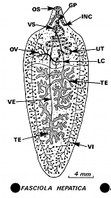
- 2 spp. Of vet . importance are Fasciola hepatica , F. gigantica.
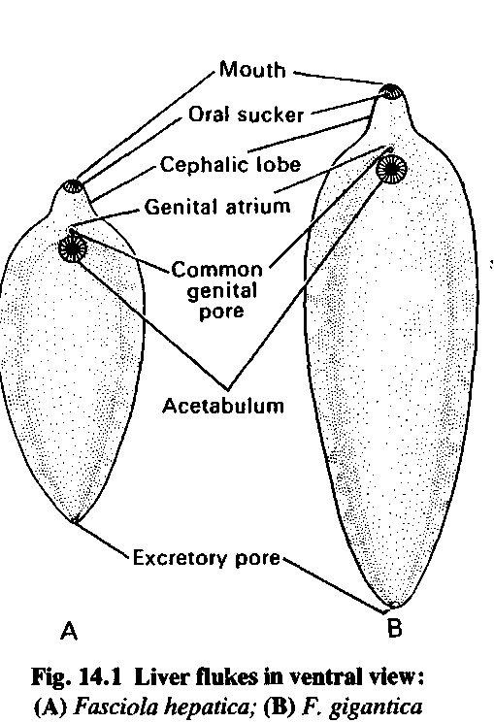

adult EX, excretory bladder; GP, genital pore; GÖ, genital bulbus; HK, hooks, spines of IN, intestine; INC, intestine (cut off on drawing); LC, ; OS, oral sucker; OV, ovary (); RS, TE, UT, uterus with eggs; VE, vas efferens of TE; VI, vitellary glands VS, ventral sucker ()

life cycle
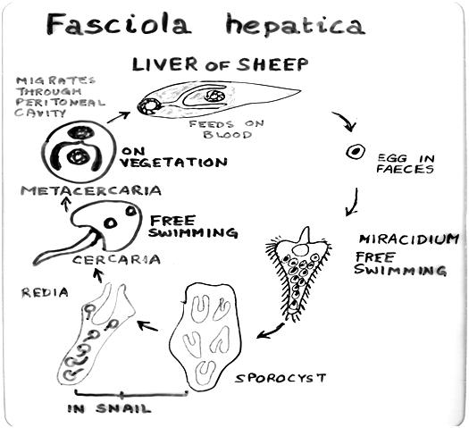

Character | Fasciola hepatica | F. gigantica.
Length | 2-3 x 1.2 cm. | 2.5-7.5 x 1.2 cm.
Shape | Leaf like gray-brownish with opposite sides | Leaf like gray-brownish with parallel sides
Cecae | Small protrusions | T or Y shape
Testis site | Mid | =
Ovary site | In front to 1st. testis | =
Infective stage | Metacercaria | =
Site of infection | liver, gall bladder, bile duct | =
Intermediate host | Amphibious snail ,  Lymenia truncatula | Aquatic Snail  Lymenia auriuleria
Life cycle period | 11-19 weeks | =
Inside sheep | 8-12 = | =
Inside snail | 3-7 = | =

- Fascioliasis Pathogenesis ; Depend on 3 factors :
- Host species , age, health status
Cattle & sheep more ↑than buffalo & goat .
Young age more ↑than older age .
- Degree of infection ::
sheep when swallow 5000 cercaria →death in 2-3 days
100-200 adults found in the liver →chronic case
50 = = = = →carrier case
- Secondary Complications :
Enterotoximeia bacteria Clostridium novyi →lead to death in 5-8 days
Stongylosis → increase animal susceptibility .
- Pathological changes causes :
- Immature flukes :
Hemorrhage, liver tissue destruction , liver cirrhosis
- Mature flukes :
liver cirrhosis , bile stones, bile duct obstruction, bile retention , obstructive jaundice
- Fascioliasis: liver fluke disease:
Fascioliasis is the disease caused by liver fluke (Fasciola hepatica). Sheep and cattle are most commonly affected and sheep are more susceptible to the disease than cattle. Horses, deer and goats may also be infected by liver fluke; humans are also occasionally infected.
Clinically 3 forms:
- Acute fascioliasis:
Acute fascioliasis occurs as an outbreak of disease following a massive but relatively short-term intake of metacercariae. This high intake is often the result of certain seasonal and climatic conditions combined with a lack of appropriate fluke control measures. It typically occurs when stock are forced to graze in heavily contaminated wet areas as a result of over-stocking and/or drought. Animals suffering from acute fascioliasis may display no clinical signs prior to death; some may display abdominal pain and discomfort and may develop jaundice. Death usually results from blood loss due to haemorrhage in the liver caused by the migration of the immature fluke through the liver.
- Sub-acute fascioliasis:
Sub-acute fascioliasis is characterised by anaemia, jaundice and ill-thrift. The migrating fluke cause extensive tissue damage, haemorrhage and, in particular, liver damage. The result is severe anaemia, liver failure and death in 8-10 weeks
- Chronic fascioliasis:
Chronic fascioliasis is the most common clinical syndrome associated with liver fluke infection in sheep and cattle. It occurs when the parasites reach the hepatic bile ducts. The principle effects are bile duct obstruction, destruction of liver tissue, hepatic fibrosis (scarring) and anaemia.
The onset of clinical signs is slow. Animals become gradually anaemic and inappetent, as the adult fluke become active within the bile ducts; signs may include dependent oedema or swelling under the jaw (‘bottle jaw’). Affected animals are reluctant to travel. Death eventually occurs when anaemia becomes severe. Additional stress upon anaemic animals, such as droving, may lead to collapse and death. Cattle typically present with signs of weight loss, anaemia and chronic diarrhoea.
Chronic fascioliasis provides the right environment in the liver for the germination of the spores of the bacterium, Clostridium novyi Type B, which cause Black disease. Vaccines against C.novyi are available and should be given to all animals, particularly those at risk of fascioliasis
- Diagnosis
a. symptoms :
Acute Fascioliasis should be considered when there are cases of death, anaemia, or chronic Fascioliasis diarrhoea or ill thrift in sheep or cattle grazing on fluke-prone country.
In the live animal, chronic fascioliasis is indicated by the presence of fluke eggs in a faecal sample sedimentation test (faecal samples may be sent to a veterinary laboratory for diagnosis ; size of eggs , diffrentitaed from Paramphistomum ).
b. P.M. :
- A dead animal can be quickly diagnosed by the presence of mature or immature fluke in the liver; the autopsy will also identify any other conditions that may be contributing to the problem. Emaciated, anaemic or edematous carcass in severe chronic infestations
- Presence of flukes in enlarged and thickened bile ducts and in the liver parenchyma
- Hepatic abscesses and secondary bacterial infection
- Calcification of bile ducts
- Black parasitic material (excrement) in the liver, lungs, diaphragm and peritoneum 6. Haemorrhagic tracts of migratory immature flukes in the lungs and liver in an acute infestation ,Black lymph nodes of the lungs and liver due to fluke excrement
- Icterus due to liver damage

- Treatment
- The treatment recommended will depend upon the nature of disease. Some of the available anthelmintics are not effective against immature fluke and so are not recommended in acute fluke outbreaks. In addition, they are less efficient for the strategic control of fascioliasis.
- At least 2 treatments annually with anthelmintics required on sheep and beef properties where liver fluke occurs. The initial dose should be administered in spring to remove any fluke that have been present in the animals during the winter. This is followed by a second dose in early summer to remove fluke picked up during the spring. A third treatment, in autumn, may be required on properties heavily infested with liver fluke.
- (closantel + oxfendazole), benzimidazole is registered for use in sheep and it is a suitable rotational product to be used with (triclabendazole), to delay the onset of resistance. (closantel + oxfendazole), will kill a high proportion of fluke aged 4 weeks and is highly effective against fluke aged 6 weeks or older. The very early immature fluke will be retarded in their development and egg production will not commence for several weeks, thus reducing the level of pasture contamination.
- Molluscicides for snails e.g. CuSO₄.
- Control of wild rabbits as carrier host.
Genus Fascioloides
Fascioloides magna, also known as giant liver fluke, large American liver fluke or deer fluke, is an important parasite of a variety of wild and domestic ruminants in North America and Europe. Encapsulated Adult flukes occur in the liver ,bile ducts of the definitive host and feed on blood. Mature flukes measure 4 to 10 cm in length × 2 to 3.5 cm in width, and have an oval dorso-ventrally flattened body with oral and ventral sucker.
It may differentiated from Fasciola hepatica by the absence of an anterior cone like projection.

Family Dicrocoeliidae
A family of flattened, translucent flukes (trematoda) , with shape as lancet ,had oral and ventral suckers ,occurring in the gut, gallbladder, bile ducts, liver or pancreatic ducts of amphibians, reptiles, birds, and mammals.
Dicrocoelium dendriticum
(Lancet fluke, Lesser liver fluke)
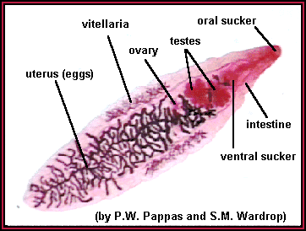
typically lives in the bile ducts of the livers of grazing animals (and sometimes humans). It has a rather typical trematode (fluke) life cycle with three different hosts but, interestingly, it clearly alters the behavior of one of them, making it more likely to reach the next host.

Dicrocoelium dendriticum Life Cycle
- Adult produce eggs exit from the bile, mixed with the stool.
- Land snails the Helicella or Zebrina as 1st. intermediate host ingest the eggs, then hatched , releasing miracidia.
- Miracidia migrate through the gut wall into the snail’s digestive gland, where they multiply asexually. Developed to 1st. &2nd. Sporocysts which are produced Cercariae.
- No redia produced .
- Cercariae gathered ( up to 400 ) and leave the snail’s tissues in slime ball .
- Formica ants 2nd. intermediate host eaten slime balls, Cercaria in brain encysted after 35 days to metacercaria( infective stage) which profoundly influences the ant’s behavior .
- Infected ants crawl on grass in the cool evenings and early mornings . This is the time when herbivores are grazing—the ant’s strange behavior makes the insect much more likely to be eaten by a grazing.
- Metacercariae in final host migrate up the bile duct into the liver and mature to adult flukes in under two months. At about three months after infection, the worms begin producing eggs.

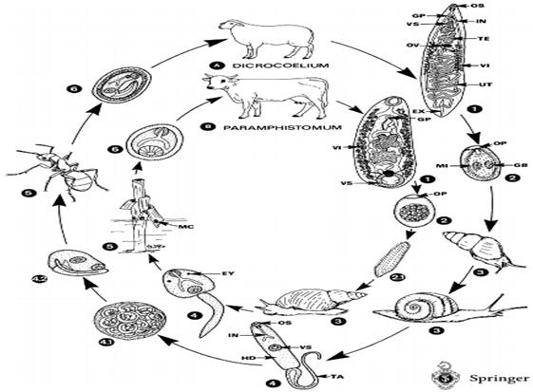

EY, EX, excretory bladder; GB, GP, genital pore; HD, head; IN, intestine; MC, metacercaria; MI, miracidium; OP, OS, oral sucker; OV, ovary; TA, tail; TE, UT, uterus; VI, VS, ventral sucker
Pathology & Clinical sings
Dicrocoelium dendriticum can infect the bile ducts ; Because the bodies of these parasites are long and narrow, infections are generally confined to the more distal parts of the bile ducts. infections of the biliary tree produce only mild symptoms. These symptoms can include biliary colic and general digestive disturbances, including bloating and diarrhea. However, in heavier infections, bile ducts and the biliary epithelium may become enlarged in addition to the generation of fibrous tissue surrounding the ducts, and as a result, causing an enlarged liver (hepatomegaly) or inflammation of the liver (cirrhosis).
Postmortem findings : In cattle, sheep and swine, the lancet fluke causes moderate thickening of the bile ducts, with slight damage to liver parenchyma. Upon close examination, the parasites can be seen in the bile ducts.
Differential diagnosis: ova 35 x45 u oval with one side rectilinear brownish colour and complete miracidium (fully embryonated ) ;see Fascioliasis.
In addition, in 2007 the WHO included Dicrocoelium dendriticum on its list of organisms to target with its Foodborne Disease Burden Epidemiology Reference Group.

